*A REPORT ON THE PROJECT-*

**ONLINE BOOK STORE**

Submitted by-

* 20BCS250- Yuvraj Singh Wahla
* 20BCS196- Sanjana Kumari Sharma
* 20BCS056- Bhukya Sanjana Rathod

Submitted to-

* **Prof. Pritee Khanna**

*PDPM INDIAN INSTITUTE OF INFORMATION TECHNOLOGY, DESIGN AND MANUFACTURING JABALPUR, INDIA*

November 16, 2021

About Our bookstore:

The project is based on a book database system pertaining to various needs of the user. The basic interface involves querying books according to language, title, author, publisher, ISBN. We support services for buying and renting books used in specific CSE Course. We build a personal profile page which is used for handling the transactions between various students.

Outline:

1. **Information regarding the book**: Set of entities that support the store of books, authors and publication and general search queries for their availability in the library.

2. **Information regarding buying/renting**: Set of entities that support personal profile of the students and transactions.

3. **Information regarding CSE books at**: The book store is all about CSE books. Description and details of all the books are available in the store.

Queries And Functionality**:**

1. In order to buy/rent the books the students need to login with a username and password and the username can be used as key for students.

2. A login id for a particular student is created when the student registers himself at the portal. The system checks for any existing user with same desired userid. If found, the system gives direction to user to choose another username. Login details are recorded in login table.

3. On logging in the system moves to home page which will show information regarding the latest books available in the store.

4. Various queries that can be taken by the user:

(a) Add a book to the cart:

Store specifies complete information regarding the book along with the information about the authors and publication details.

The person can save their books and book details in the cart if they wish to buy it later.

(b) Buying a book/rent a book:

We provide a quick purchase strategy in the search itself. As soon the person clicks on the purchase button, a webpage requiring information for payment options open. The details of the orders are recorded in the order tables.

(c) Course Books available:

The store contains CSE books and it also has description and details of all the books available. There are also list of various publishers who published the books.

Tables:

1. Books(book_isbn, book_title, book_author, book_image, book_descr,book_price,publisherid)

2. Admin(name, pass)

3.customers(username,name,address,city,zip_code,country)

4.customer_login(username,password)

4.Orders(orderid,customerid,amount,date,ship_name,ship_address,ship_city,ship_zip_code,ship_country)

5. publisher(publisherid,publisher_name)

6. Order_items(orderid,book_isbn,item_price,quantity)

Non-Trivial Functional Dependencies

1. Book:

Book_isbn-> (book_title, book_author, book_image, book_descr,book_price,publisherid)

2. Admin:

name-> (pass)

3. Customers:

username->( name,address,city,zip_code,country name,address,city,zip_code,country)

4. customer_login: No functional dependency

5.Orders:

orderid-> (customerid, amount, date, ship_name, ship_address, ship_city, ship_zip_code, ship_country)

6.publisher:

publisherid->(publisher_name)

7. Order_items: No functional dependency

Technology Used:

The project was coded in *PHP 5* with database implementation in *mysql*. We also used *bootstrap* along with *HTML* and *CSS*. Session Variables have been used to maintain data during navigation between different pages.

ER Diagram:

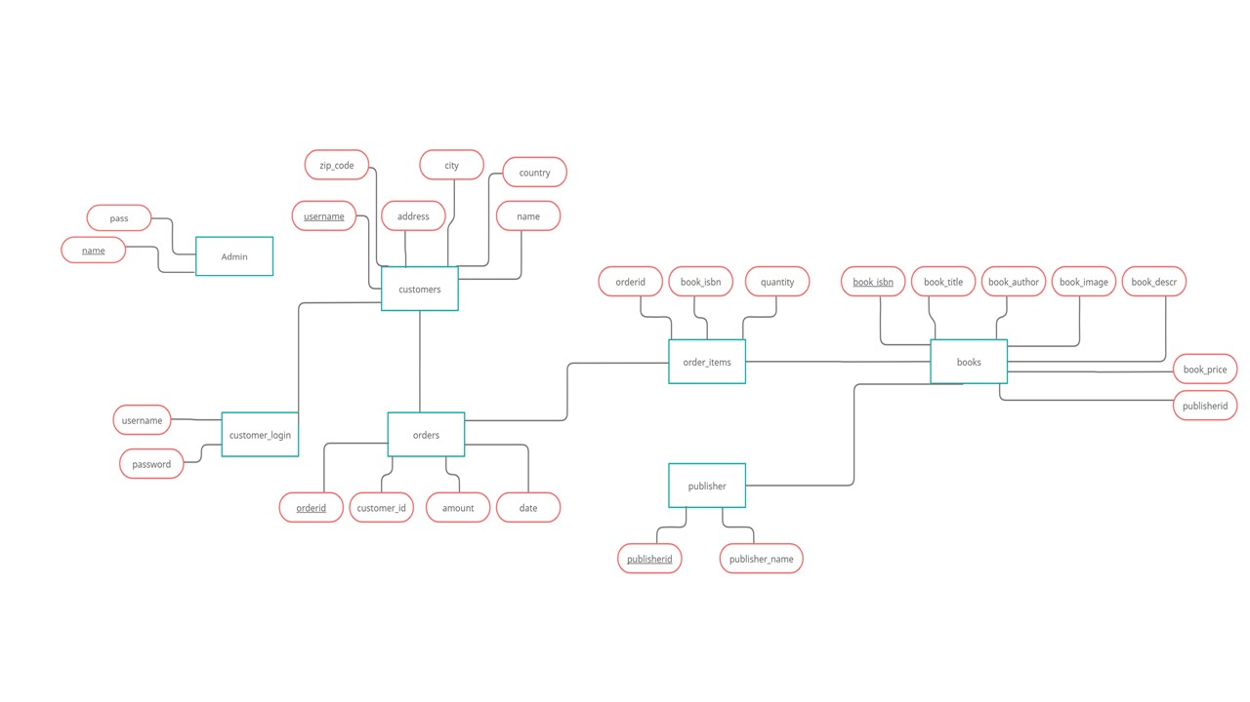

Relational Diagram:

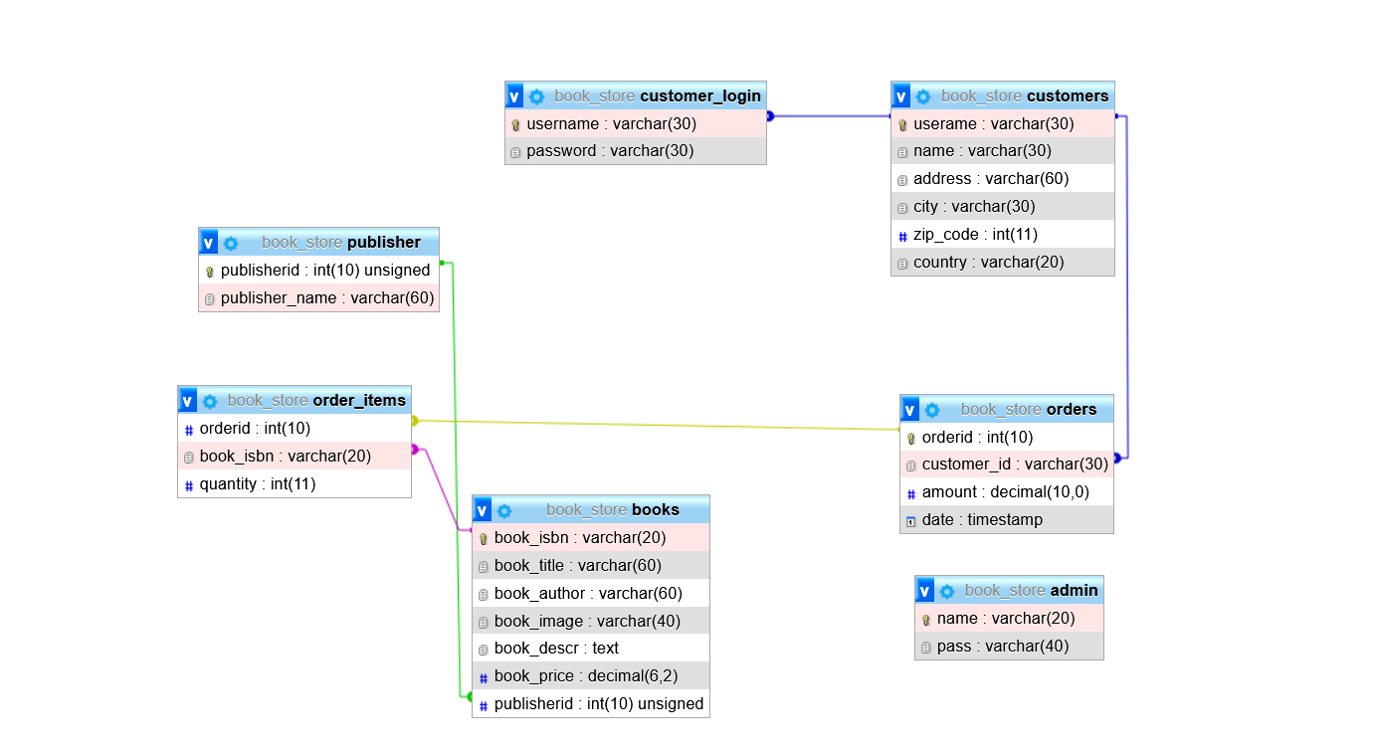

Project Screenshots:



